AWS EC2(Server Hosting)

# **Launch Instance**

**Step 1:-** Open AWS Console and Login with Root User

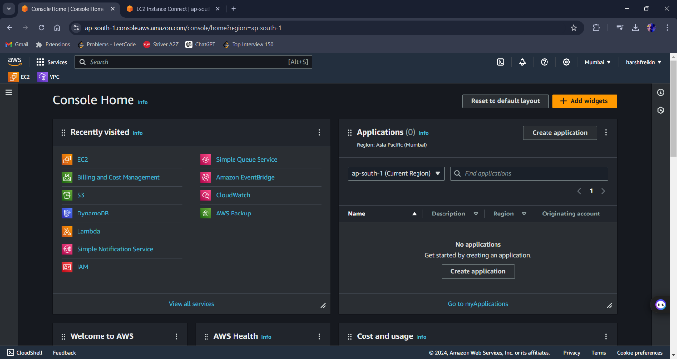

**Step 2:-** Search EC2 in search bar

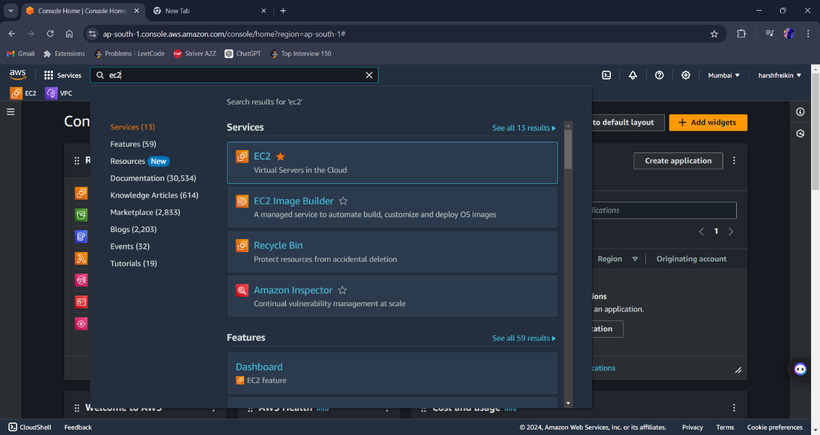

**Step 3:-** Click on EC2 option and EC2 window now open

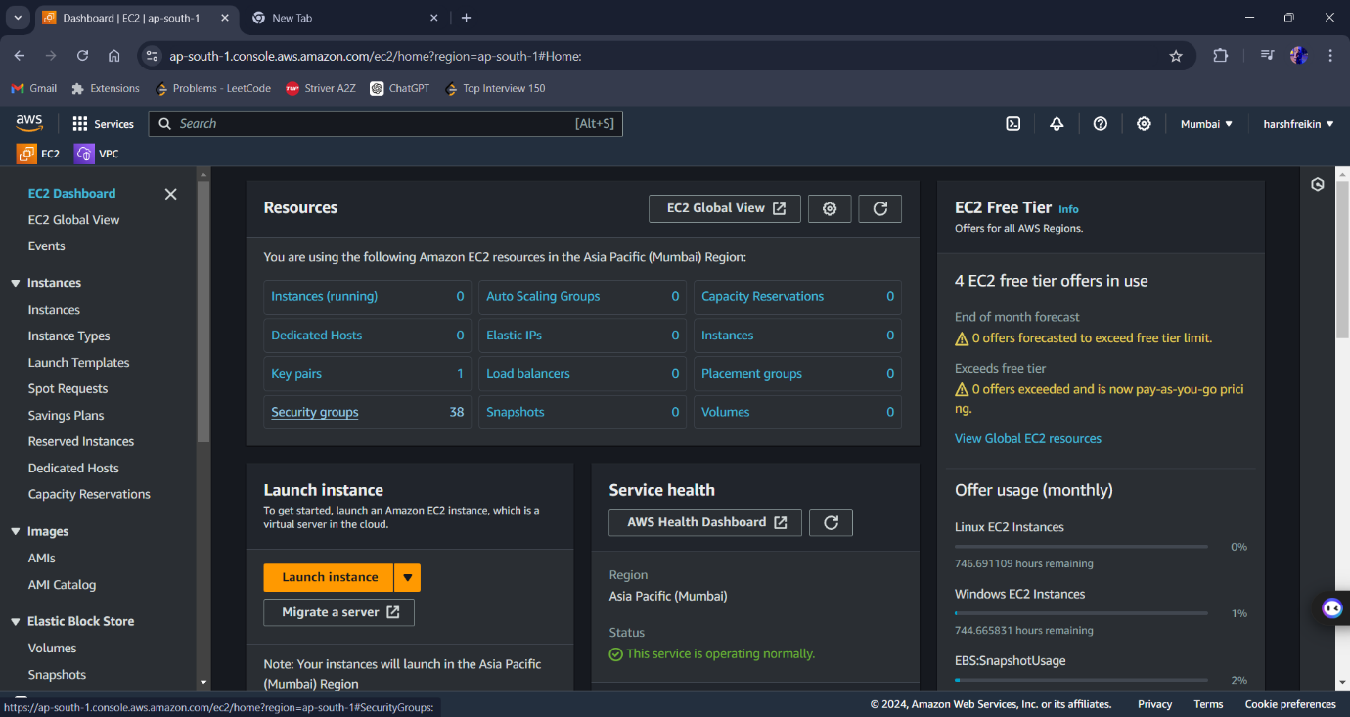

**Step 4:-** Click on Launch Instance [yellow box] and new window opens.

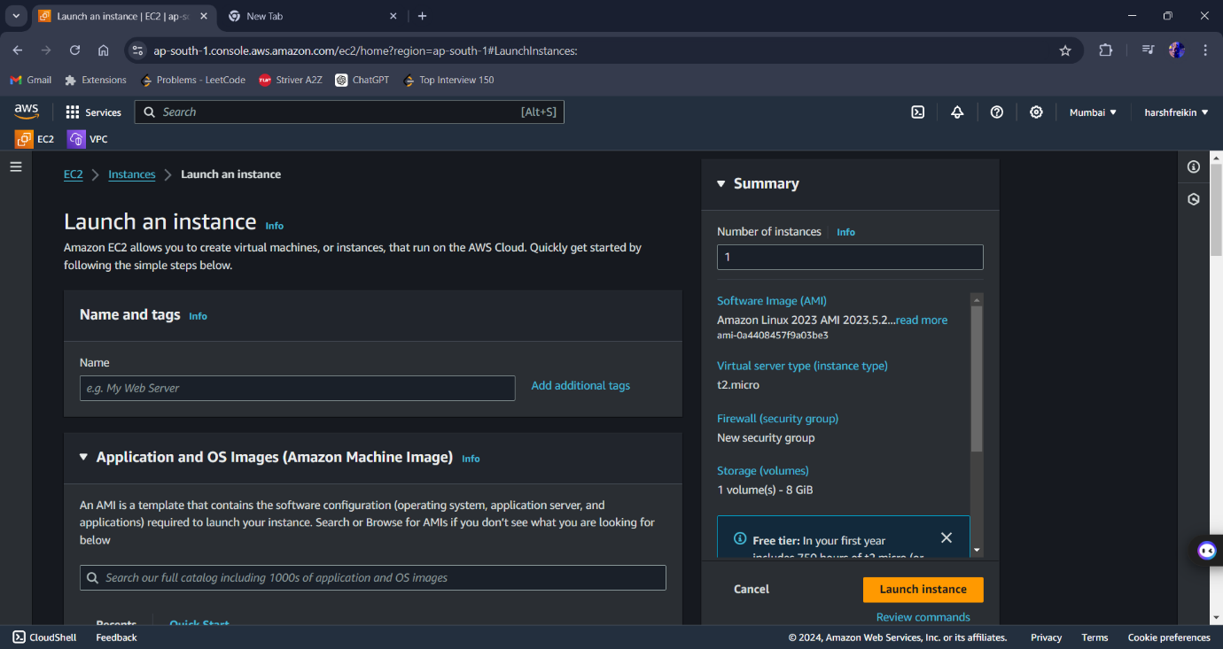

Step 5:- Now user enter step by step all details

* Enter Name First
* Select the Operating System which you want

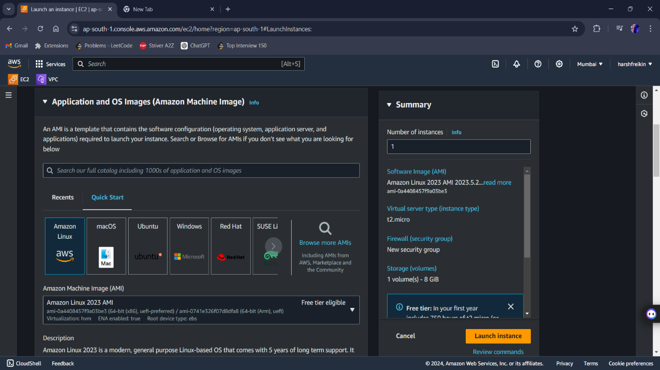

* Now create key
* Select the Instance type

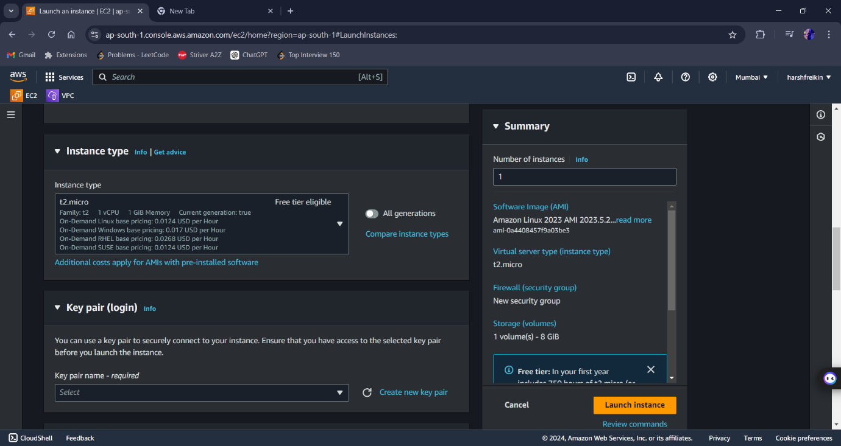

* Edit the network setting by edit the VPC, Subnet and security or check the box

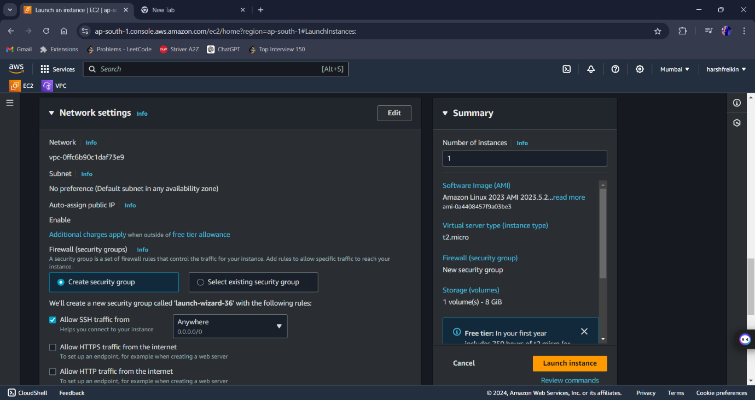

* You can also Add the volume or select different type of volume i.e., gp2,gp3 and so on.

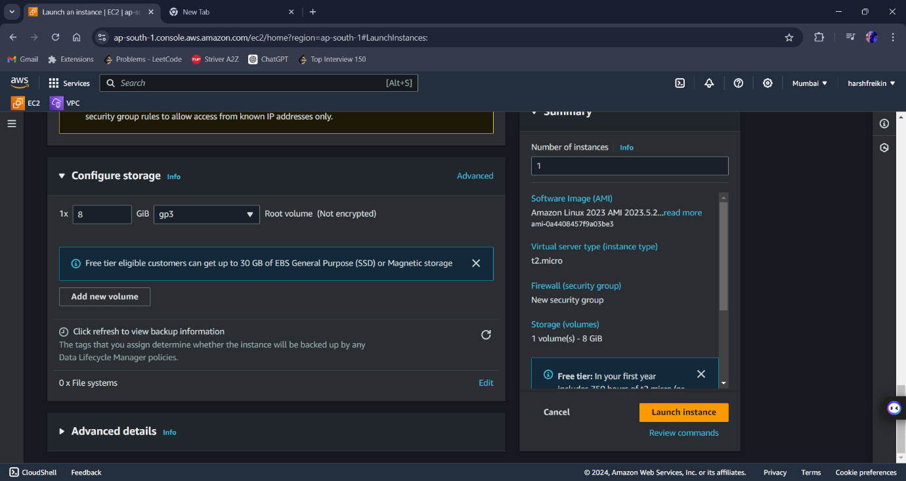

**Step 6:-** Lastly click on launch Instance option to launch the instance.

# **Connect Instance to the Server (Operating System:- Window)**

**Step 1:-** Select the Instance which you want to Connect and click on Connect option present on the Top.

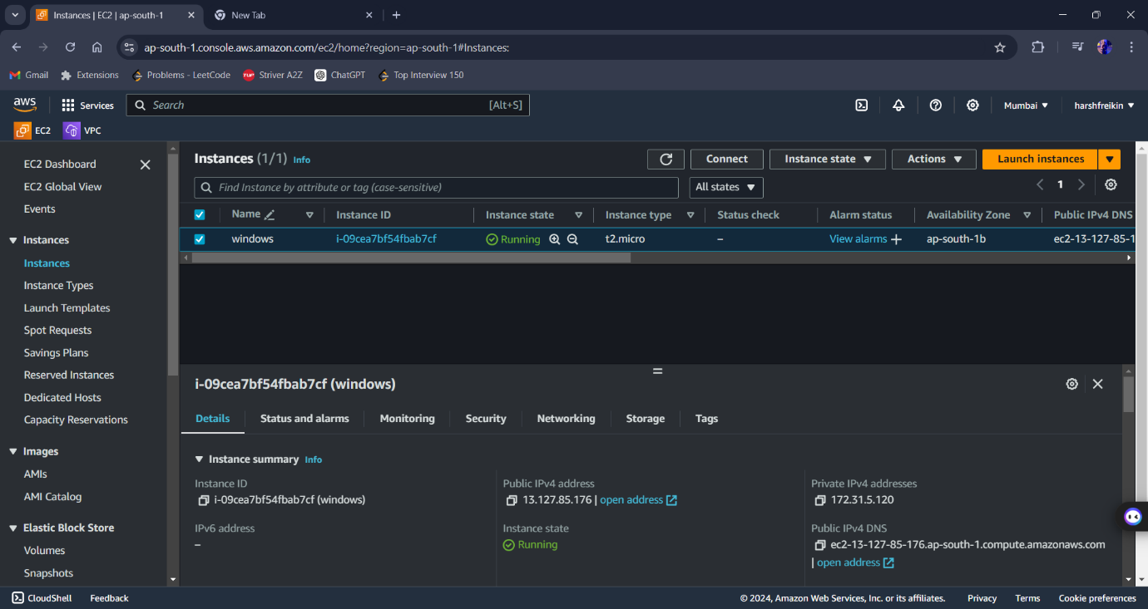

**Step 2:-** Now New window open and click on RDP client

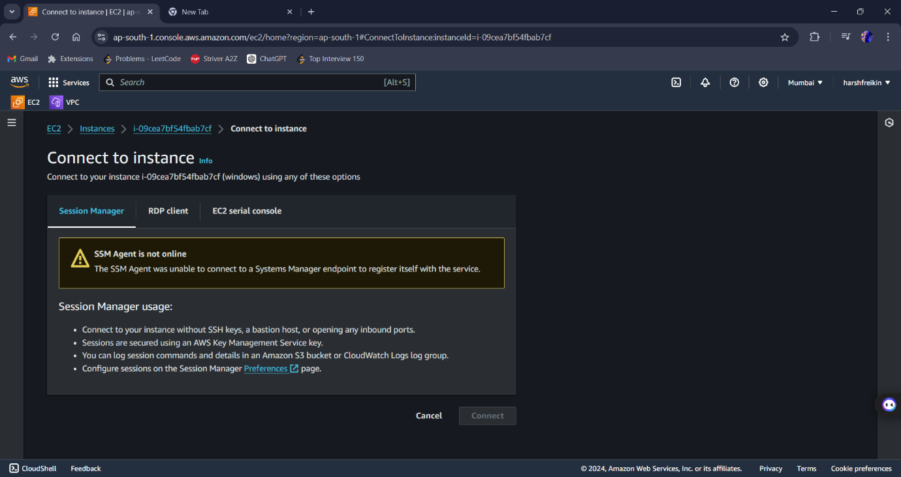

**Step 3:-** Download the remote desktop file after that click on get password option.

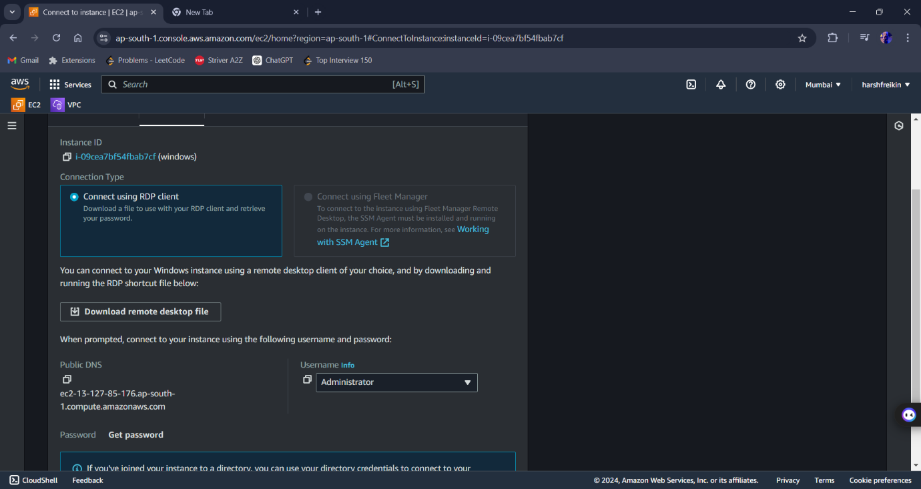

**Step 4:-** Upload the private key file and Click on Decrypt password.

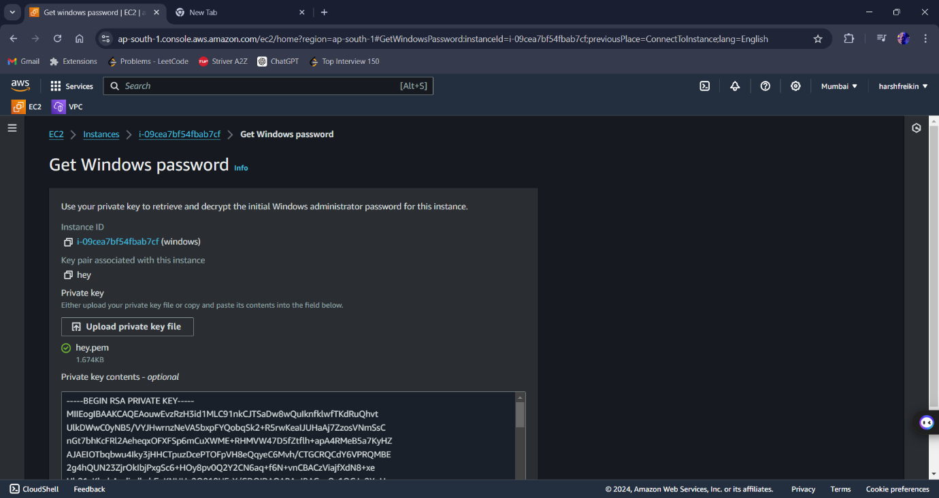

* Now user get the password to connect the Instance.

**Step 5: -** Now User click on download option and select the remote desktop file (server2.rdp).

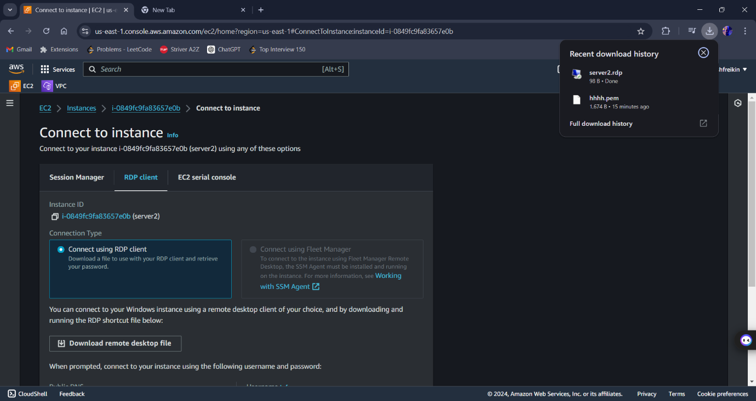

**Step 6: -** Now user copy the Password which was decrypt earlier and paste it and click on OK button.

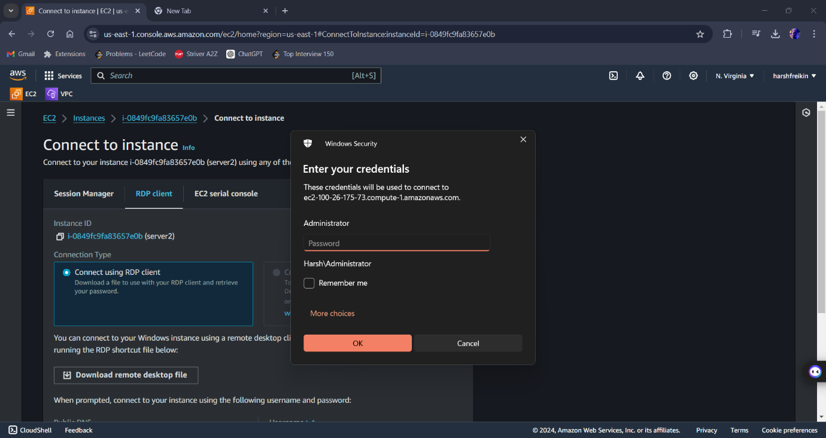

***Now server is Connected and open***

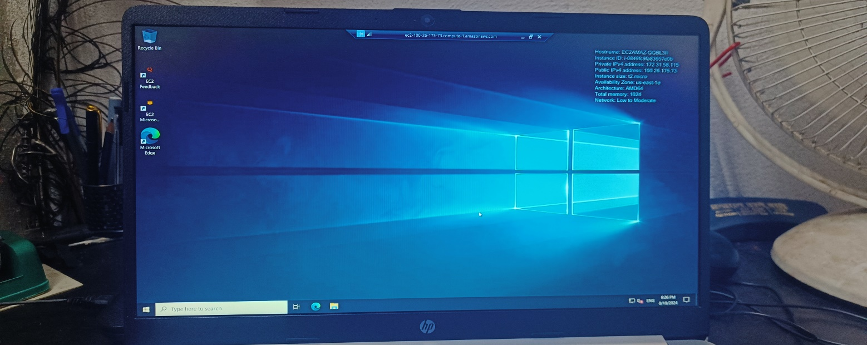

**Step 7: -** Search Server Manager on windows Tab and click on it.

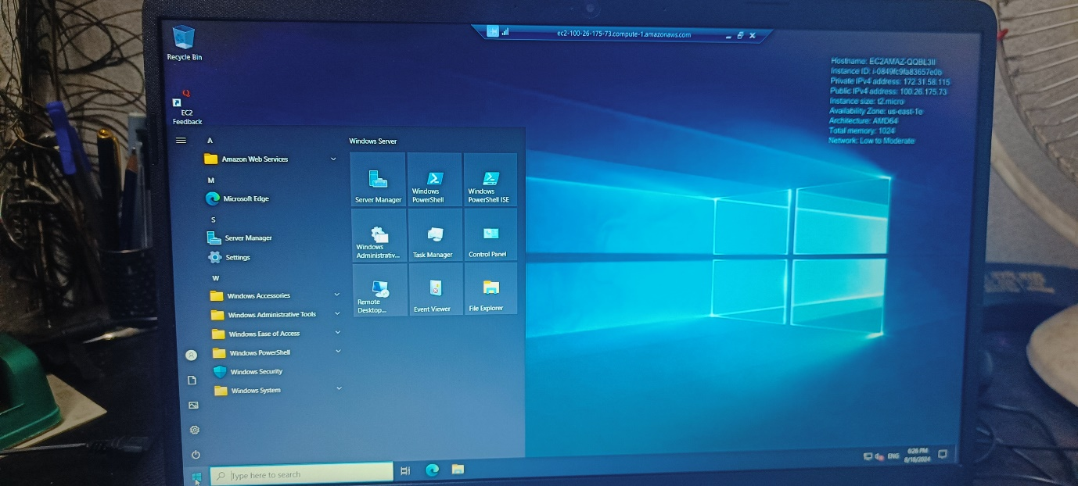

**Step 8 :-** After opening click on role and feature option.

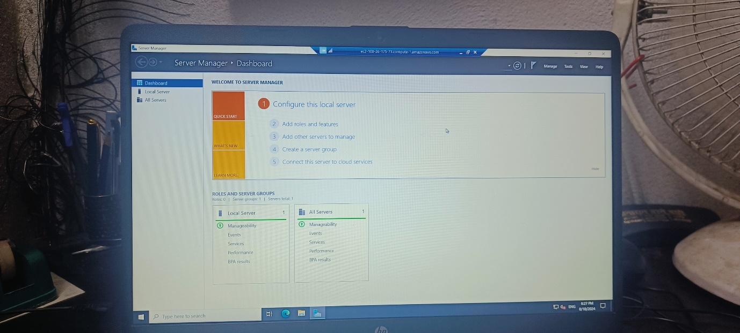

* Then click NEXT -> NEXT -> NEXT

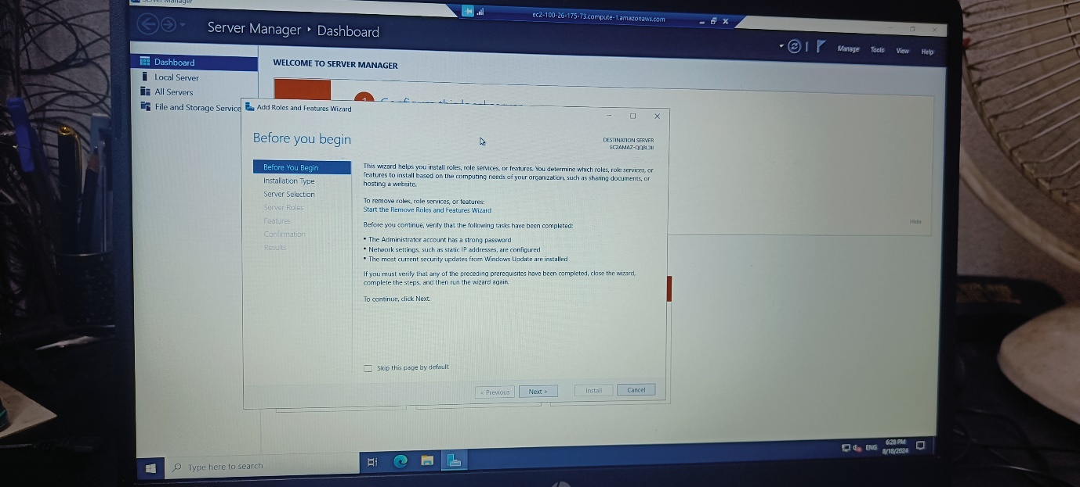

* Select WEB ISIS and click NEXT -> NEXT -> and lastly INSTALL

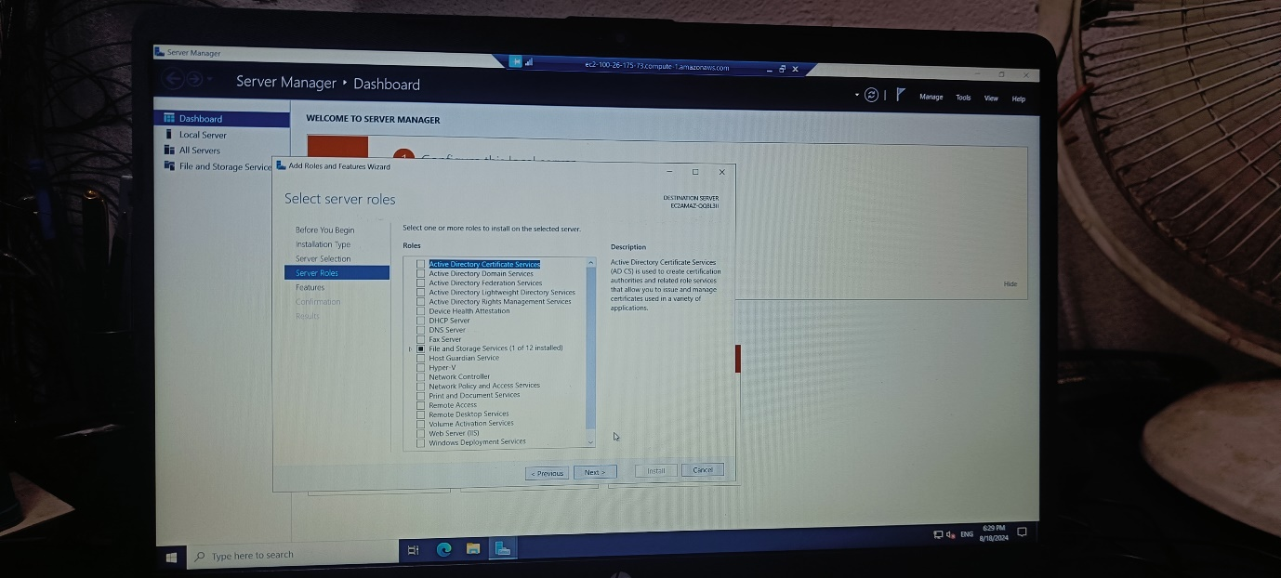

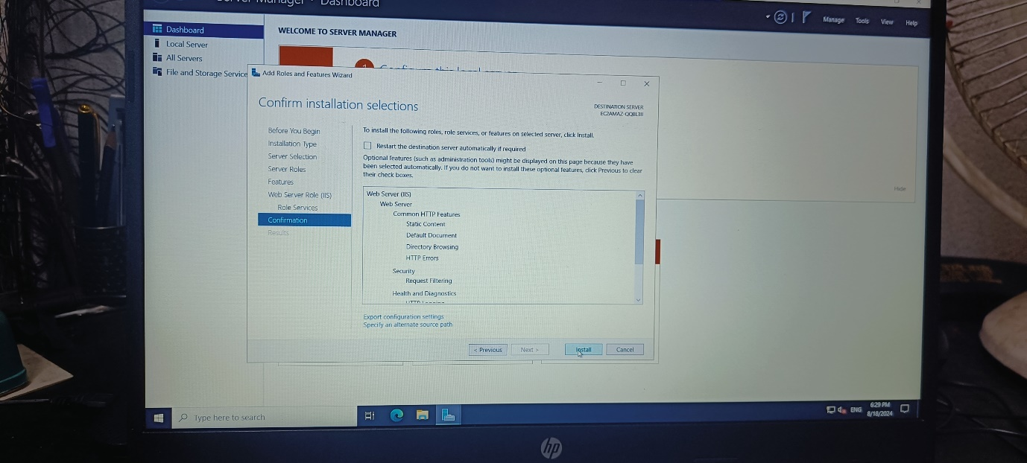

**Step 9 :-** Go to C Drive and click on initpub.

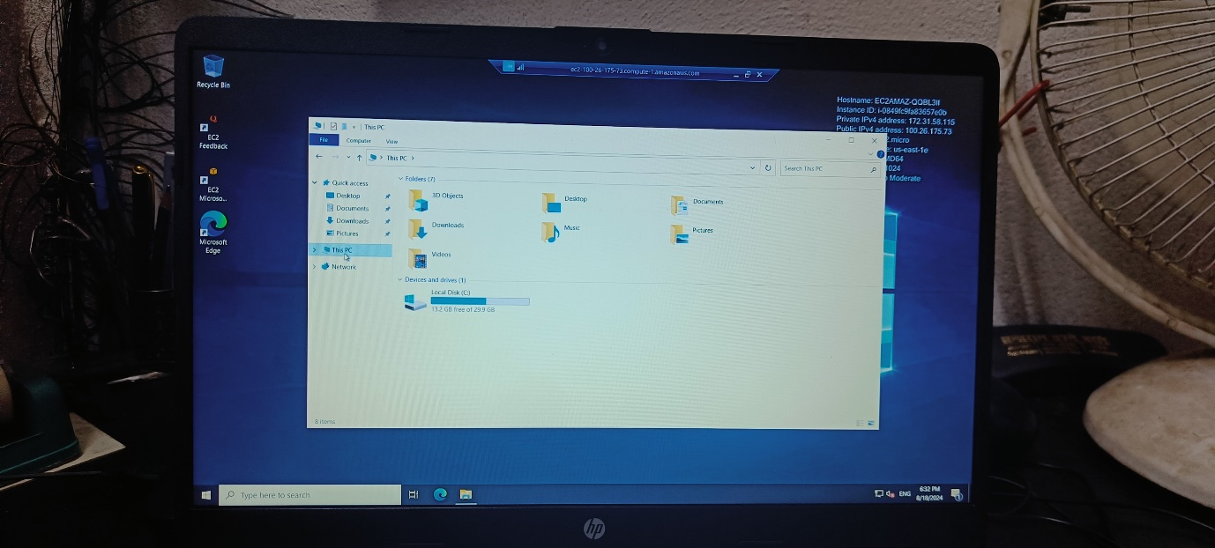

**Step 10 :-** Now click on wwwroot.

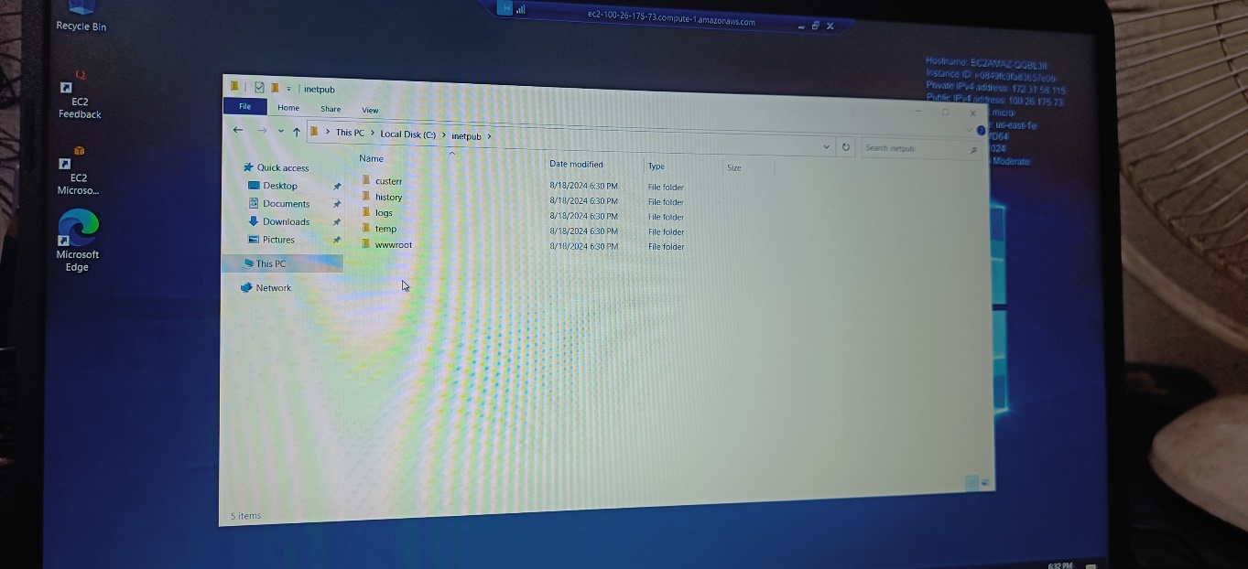

**Step 11:-** Delete existing files and add new document file.

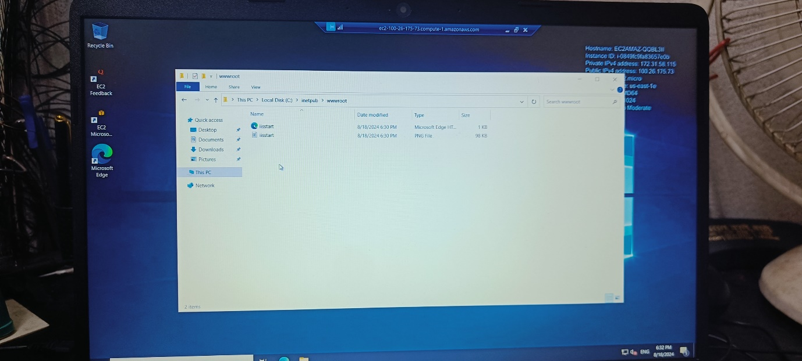

**Step 12: -** Now paste the code of your website and go to file, select save as and save with .html extension.

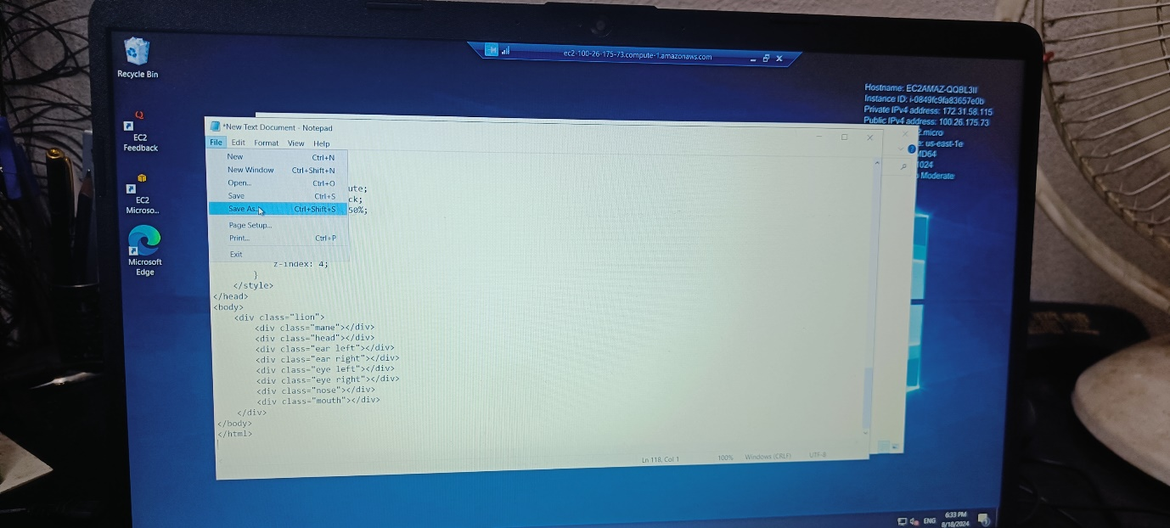

**Step 13: -** Go back to the Instance Window and copy the Public IP4V address.

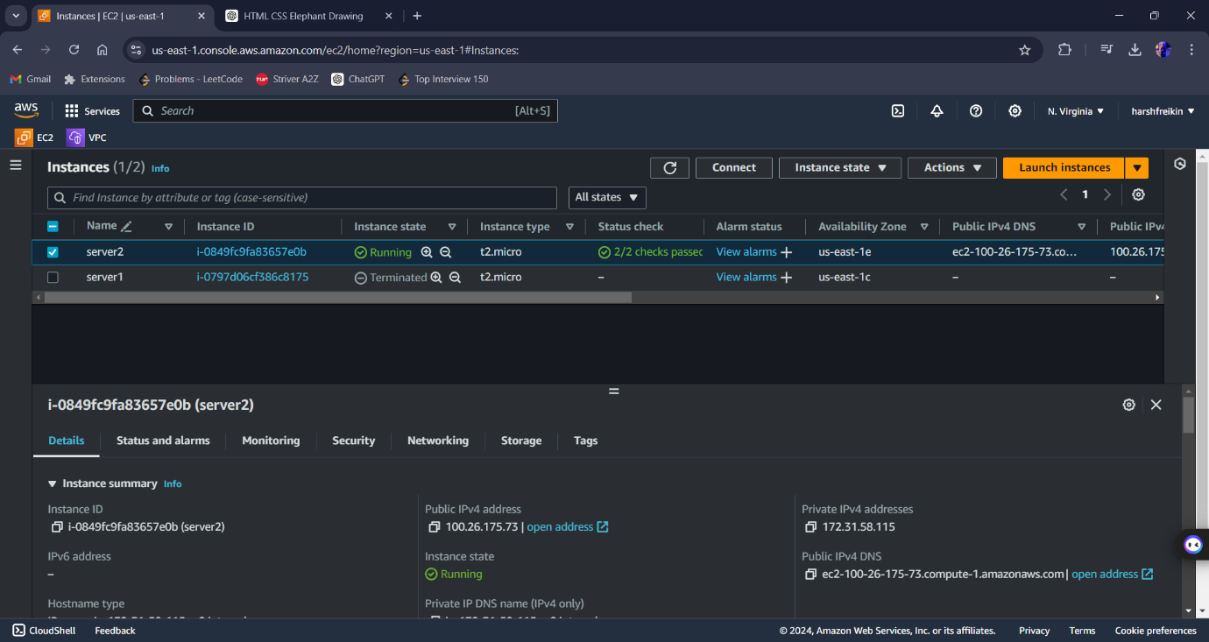

**Step 14 :-** Paste the address in browser and press enter

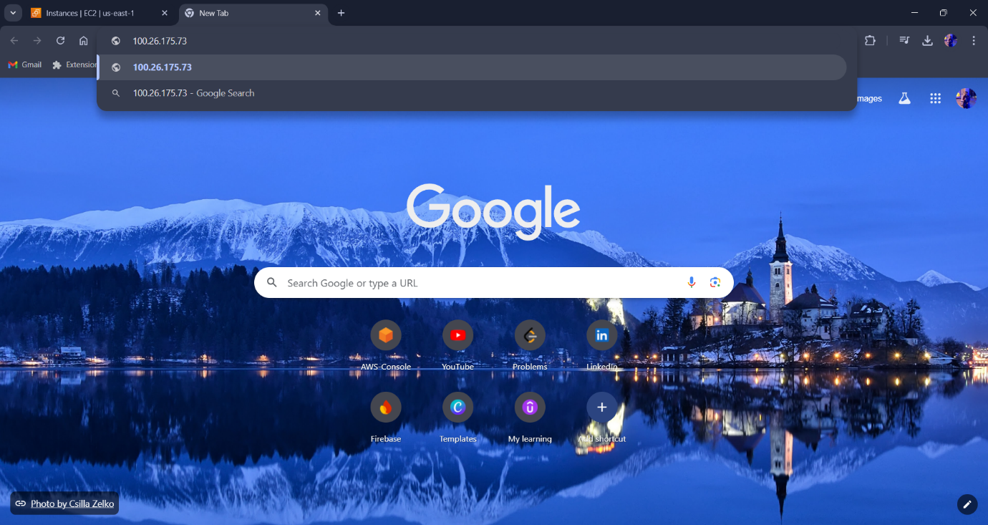

**Step 15 :-** And your web server launch and your content is visible

